Dental Public Health Journal Club
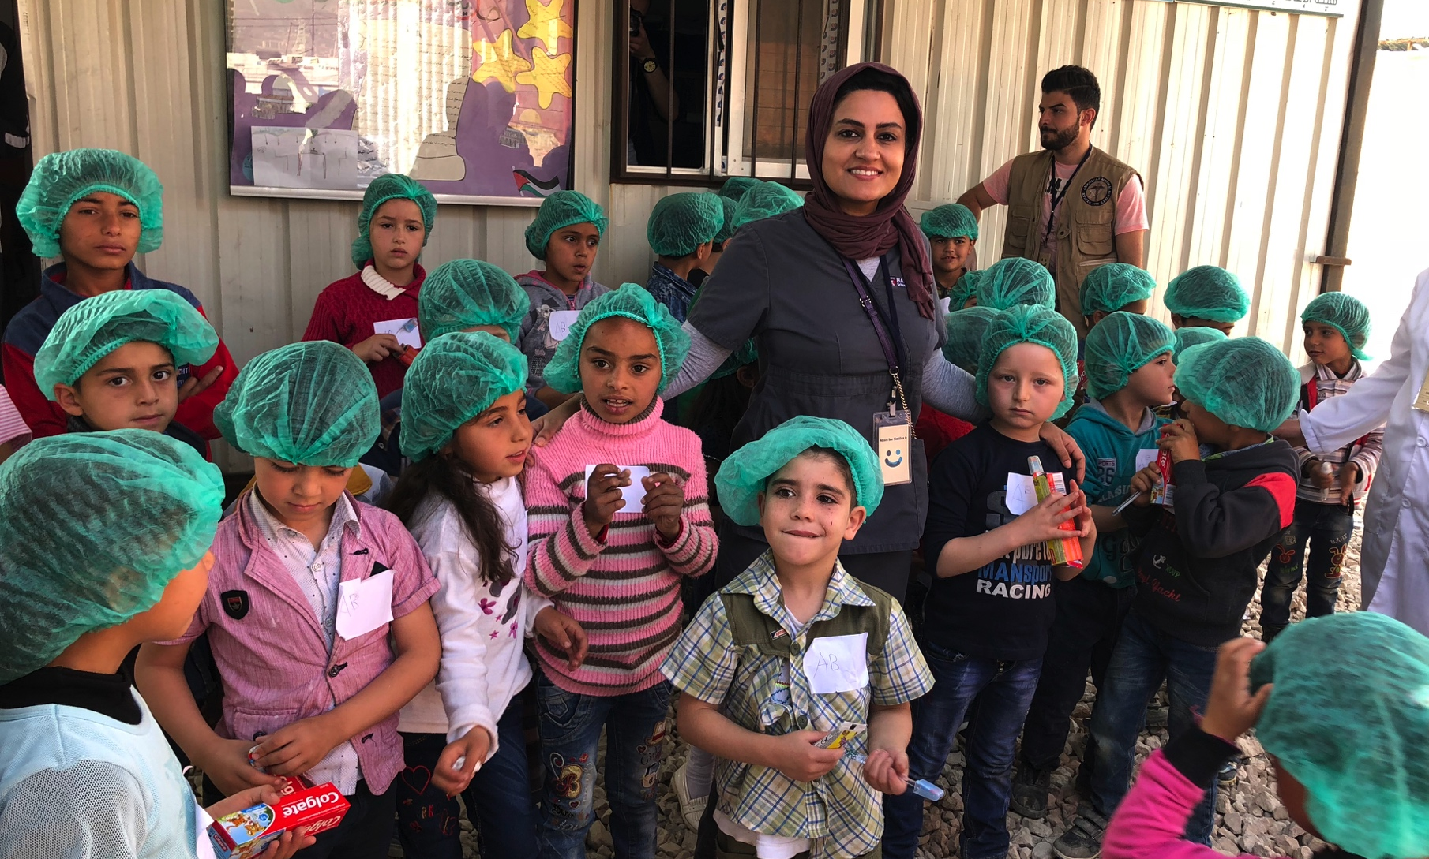

Miles for Smiles: A Sustainable Dental Prevention and Treatment Program at a Syrian Refugee Camp in Lebanon

Dr. Hend Alqaderi & Dr. Brian Swann

Tuesday July 10th, 2018
5:30 - 7:00pm
REB 109
Dr. Swann and Dr. Alqaderi will share their stories and experiences in delivering dental care to children at a Syrian refugee camp in Lebanon. In addition to implementing a dental protocol every six months, Dr. Swann and Dr. Alqaderi will share their future plans in evaluating the effectiveness of this protocol for sustainability, future improvement, and quality assurance.

